Rising bollard product manual

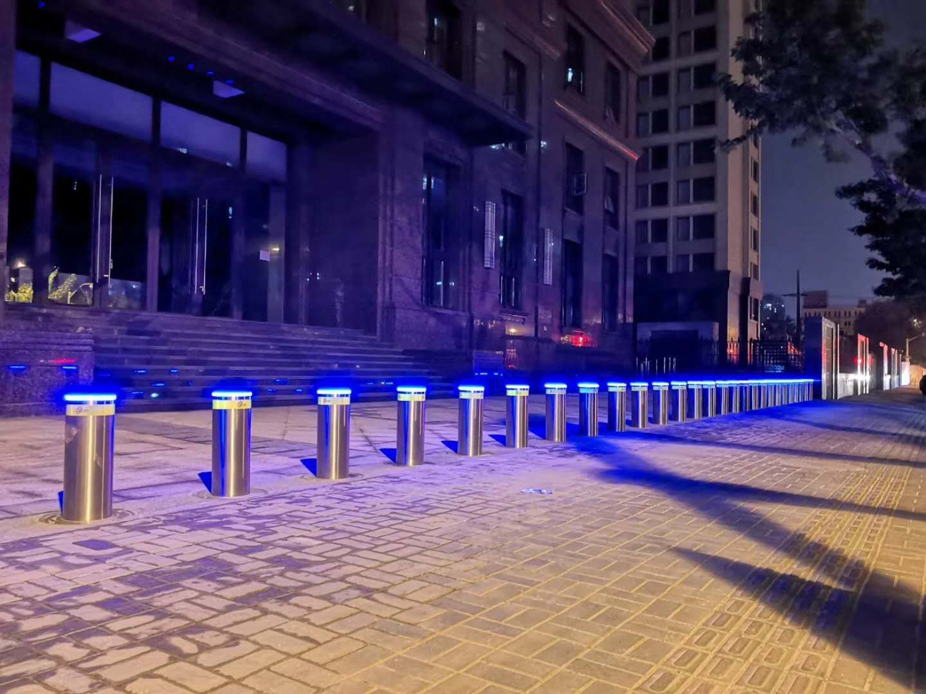

Shenzhen TDZ Tech Co.,Ltd
Add:West 3rd Floor C building Kelunte Low-Carbon Industrial Park,Huarong Road,Dalang,Longhua district,shenzhen,China

Web: Http://www.luckgates.com www.tdzgs.com
Tel:0755-23462586

Rising bollard product specification and installation process
First, product overview
The electro-hydraulic rising bollard is an automatic lifting road pile with a motor and a hydraulic cylinder as a power unit. The rising bollard integrates the motor and the hydraulic cylinder to form a hydraulic driving system, and drives the hydraulic cylinder to rise and fall by the motor running to control the lifting and lowering of the bollard. Through the restrictions on passing vehicles, the traffic order and the safety of major facilities and places are effectively guaranteed.

Second, the product use occasions:
◆Science and education units: schools, computer rooms, research centers, libraries, etc.;
◆ Leisure and entertainment places: parks, scenic spots, pedestrian streets, municipal squares, playgrounds, etc.;
◆ Transportation points: bus stations, railway stations, subway stations, airports, etc.;
◆ Commercial service places: hospitals, banks, hotels, clubs, commercial buildings, etc.
◆ Office space: office buildings, public security units, water, oil and gas units, etc.
Third, product structure introduction:
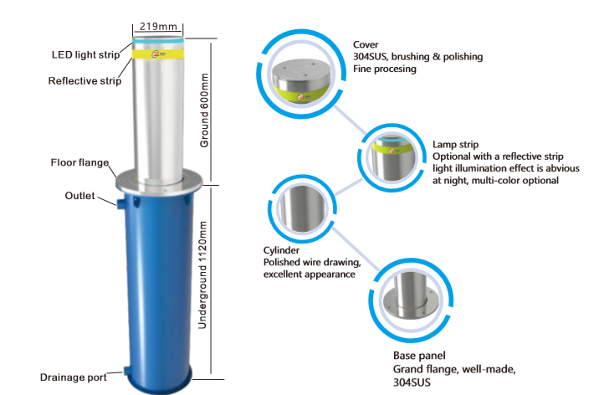

Fourth,rising bollard technical parameters:
Parameters |  | Function | Parameters | Function
power supply | 220V/380V |  | frequency | 50HZ
power | 5W-350W |  | Rated speed | 2800rpm
Current | 1.3A--1.6A |  | Over current and over voltage protection | have
Rise Time | ≤4s |  | Fall time | ≤2s
Stroke height | 600mm+10mm customized  750mmor800mm |  | Lifting force | 200kg
diameter | φ168mm/φ219mm/φ273mm,±1mm/ customized |  | Thickness of the cylinder | 6mm/8mm/10mm/12mm/15mm/20mm,±1mm
Cylinder material | Cylinder304 stainless steel |  | Buried outer cylinder | Q235material，Paint
Emergency treatment | Electromagnetic pressure relief, backup EPS、DC12V |  | working frequency | 1---2times/minute
Limit mode | Mechanically adjustable limit |  | Service life | 3 million times
Manual disassemble | Detachable |  | Minimum traffic pressure | 80 tons container truck
Leading speed | ≥120mm/s |  | Compression speed | ≥220mm/s
power | 65% |  | Motor wiring | 1.5M
Sealing method | One-piece seal |  | Drainage method | Natural drainage + external drainage system
Operating temperature | -45℃--+75℃ |  | Use altitude | Not more than 6000m
Protection level | IP68 |  | Use humidity | 100%

Five. Preparation of materials and equipment for construction site before equipment installation
1. Stone: The bottom of the foundation ditch is covered with a layer of 3-5 cm in diameter and 20 cm in thickness.

- Sand: 20 cm above the water seepage layer of the foundation ditch. The amount of stone and sand is calculated by multiplying the length of the ditch by the width of the ditch. The width of the road pile equipment is 1 m, and the distance between the ditch and the center of the installed pile is 1 m. Or according to the length of the site construction.
- Reinforcement: The underground piles of the road piles are used to reinforce the welded steel bars. The diameter of the 1.4mm threaded steel bars is 6 pieces according to the length of the groove. According to the width of the groove, each of the pre-embedded barrels is slightly longer when welding. It needs to be inserted into the four walls of the foundation trench, which is stable and not displaced after the equipment is buried in the barrel.
- Concrete: Calculated according to the base area of the base and multiplied by 90cm, the pavement recovery cement or asphalt stone is calculated according to the field usage.
- 1 inch thick-walled polyethylene plastic pipe, according to the distance of each road pile to the control box on the site and make a reservation, each road pile is the root, the control box is required to be buried between the power box and the cable box. Pipe protection.
- Cable: Control box input main voltage 220v (RVV 3*4m2) 380V input: (RVV 3*4m2+1), cable. Control box to road pile equipment cable (the road pile with warning light cable is RVV7*2.5m2; the road pile without warning light cable is RVV5*2.5m2; two lines can also be used, road pile with warning light RVV3* 2.5m2+RVV4*1.0m2; road pile without warning light RVV3*2.5m2+RVV2*1.0m2), one for each road pile. One roadblock equipment grounding wire (BVR4m2). The required cable lengths are reserved at both ends of the distance between the site control box road pile equipment and the control box to the power supply equipment.
- Cable wiring tape: electrical plastic tape, high-pressure waterproof tape, asphalt tape, prepared according to the number of field devices.
- Tools and equipment: welding equipment, pavement cutting equipment, electric picks, foundation trench excavation machinery, and other electrical and civil construction tools and equipment, and on-site safety construction facilities.
- After the on-site installation materials and our company's equipment are ready, follow the relevant safety construction standards and do site construction safety measures. Determine the installation location of the road pile equipment: no pipelines, cables and other facilities that affect the construction, refer to the construction standards of the relevant local facilities.
- After the site has the construction conditions, determine the installation and construction date, arrange the technicians as needed, and call or install the instructions on site.
Sixth, equipment installation foundation construction standards
1, foundation trench excavation construction: foundation groove depth (1.4 m), width (0.7 m - 1 m), length (according to the total distance of the center distance of the road pile equipment installation plus 1 m) required to do the necessary before construction The construction plan will avoid damage to the road surface and other facilities outside the construction area and the construction area during construction.
2, according to the design plan on the installation site ground, draw the construction area of ​​the foundation ditch, if the road surface is cement, asphalt and other hard roads, first use the chainsaw to saw along the four sides of the construction area of ​​the foundation ditch, and then use the electric raft The electric equipment removes the ground above the area to avoid affecting the ground outside the construction site, which brings inconvenience to the road surface after installation.
3, the basic ditch requires four walls vertical ground leveling specifications.
As shown in Figure 4, if there is frequent water accumulation at the construction site or the groundwater level is high, our technicians will set up the corresponding drainage facilities according to the site conditions. If our personnel are not on site, please contact our technical staff to communicate with us. solution.
5. After the foundation trench is dug, the bottom is filled with 3-5 cm of stone, and the thickness of the seepage layer is 20 cm----30 cm and then filled with fine sand with a thickness of 10--20 cm. The layer thickness is even and flat, which does not affect the placement of the ultra-flat base of the pre-buried barrel.
Seven, equipment embedded parts installation
1. Laying equipment installation horizontal line: along the vertical direction of the foundation ditch [the direction of the ditch], the two ends are pulled straight with the rope at the horizontal level, and the horizontal direction [the direction of the ditch] is drawn according to the center of each installation position and the ground level. A line that forms the device to install a crosshair. It is required that the ends of each line be fixed with steel nails and not displaced.
2. Backfill or clean the fine sand at the bottom of the foundation tank according to the height of the pre-embedded barrel of each equipment, so that the height of the pre-embedded barrel of each equipment above the basic tank is the same.
3. Ultra-flat base installation: Open the equipment packing box, take out the pre-buried barrel super flat base, install the adjustment anchor bolts on the base, four on each base, put the prepared pre-embedded barrel super flat base into the foundation At the bottom of the trough, the ground feet are facing downwards, and the vertical position of each equipment installation position is perpendicular to the intersection line. The height of the pre-buried barrel super flat bottom and the upper cross line is determined by the height of the equipment pre-buried barrel. The horizontal ruler is super flat in the cross direction, and the installation of the super flat bottom plate must be horizontal, highly accurate, and firm and not displaced.
4. Equipment disassembly: After the pre-buried barrel super flat base is installed, the overall road pile equipment will be placed vertically to avoid the loss of personnel and equipment. Disassemble the top cover, flange, bollard and power unit of the equipment leaving only the pre-buried barrel section. (Refer to product technical guidance)
5. Pre-buried barrel placement: Place the pre-embedded barrel vertically on the ultra-flat bottom plate at the bottom of the foundation trough. It is required to be consistent with the upper horizontal line to ensure that the center of the pre-embedded barrel is consistent with the center line and is vertical. It is simple to fix with steel bar welding, so as to avoid the pipe threading of the lower pipe.
Eight, laying the threading pipe and threading
1. Prefabricated threading pipe laying: Pay special attention to [there are one pre-embedded pipe on each side of the equipment pre-buried bucket, the lower part is the drain pipe and the upper part is the electric wire pipe. The threading pipe can not be connected to the lower drain pipe, otherwise Other units of the device will not be installed]! ! ! ! ! Insert one end of the 1 inch threading tube into the pre-embedded barrel and hold it with waterproof tape. Insert the depth to about 30MM, and the other end to the equipment control box, one for each pre-embedded barrel. When laying the threading pipe, it is required to ensure smooth threading and cable replacement when there is a fault.
2. Threading and grounding: Each barrier device is individually driven by a cable (the barrier is illuminated with RVV7*2.5 cable; the non-lighting strap is RVV5*2.5 cable or other specification cable), to the control. A separate threading pipe is required for each cable. It is required that no cable is inserted into the pre-embedded bucket, and it is taken out from the pre-buried bucket to the top of the pre-embedded bucket, and is 1.3 meters above the top of the pre-embedded bucket. 0.7 m, the grounding wire uses a BVR24m2 alone. One end of the wire is connected to the grounding bar of the control box, and the other end is connected to the welded steel bar of the pre-embedded copper. A m8 screw is welded on the reinforcing bar and pressed with a screw cap.
3. Control box power supply connection: a cable is laid from the control box to the power take-off box. The input voltage of the control box is 380V, RVV4*4m2 is selected, 220V is selected as 3*4m2 cable, and the threading pipe is separately prepared, and the cable is required to be controlled. The inside of the box is reserved for 1 meter, and the side of the power take-off box is reserved according to the terminal in the power take-off box.
4. External controlled button box wiring: If the user requests to configure external manual button control, lay a (RVV*1.5m2) cable along the control box to the manual control box, and lay the threading tube separately, requiring the cable at the bottom of the control box to be reserved. Not less than 1.2 meters, there are external control terminals in the control box, open, close, stop, common four terminals, open, close, stop three lines are respectively connected to the corresponding button on the manual control box normally open point, the common line at the same time Connected to the other end of the normally open point of the corresponding three buttons
Nine, welding pre-embedded barrel reinforcement
1. Rebar welding process: After the cable is laid, it is necessary to reconfirm the intersection line between the pre-embedded barrel and the foundation ditch, and start welding after height, vertical and concentric level.
2. The first layer; welded with a steel bar into a well-shaped fixing frame centered on the pre-buried barrel, welded and firmly welded three layers, requiring two ends of the steel bar to be inserted into the four walls of the foundation ditch, the first layer is from the bottom of the pre-buried barrel
30 cm, after the welding is completed, the pre-buried barrel is corrected again, and it is determined that the second layer is welded after being prepared, otherwise the pre-buried barrel cannot be corrected after the second layer is welded.
3. The second layer is the same as the first one, welded in the middle part of the pre-embedded barrel, and the third time is 20 cm from the upper part of the pre-embedded barrel (the welding method of the steel bar can refer to the product technical guide to install the welding schematic)
Ten, the wiring part of the process
1. Road pile equipment power unit reserved line: The road pile power unit motor is a three-core cable line followed by a blue line. The brown line, the flower line and the solenoid valve are two black lines, and there is a two-core spiral light line with warning lights. There are seven lines, five lines without warning lights, and the pre-embedded barrel fixed steel bars are welded. wiring.
2. Wiring process: Put the power unit hydraulic integrated machine on the ground side of the foundation groove of the pre-buried barrel, and connect the seven-core cable drawn from above the pre-embedded barrel to the motor line, battery valve line and warning light of the power unit. on-line. Accurately remember the line number or color of the seven-core cable, and the color of the wire corresponding to the motor, battery valve and warning light on the device, so as to avoid the wrong connection of the control box.
3. Equipment wiring description: The 3 lines of the motor line on the road post are on the blue motor, the brown motor, and the scribing motor are common. The terminal corresponding to the control box cannot be reversed. Two separate black wires of the battery valve are connected to the battery box of the control box and the common terminal of the battery valve, regardless of the positive and negative poles. The two wires of the warning light wire are connected to the common terminal of the control box warning light and warning light, regardless of the positive and negative poles.
4. Wiring standard: After the wire is connected, it is required to be soldered with solder. First, wrap it with plastic tape, then wrap the two layers with high-pressure waterproof tape, then wrap it with plastic tape, and finally wrap it with electric asphalt tape. After the line is connected, the wiring of the terminal is trimmed and fixed under the power unit to prevent the external force from breaking the wiring. After finishing the work, first connect the two wires of the power unit to the warning light, and measure the other end of the cable with a multimeter. The three wire motors are open, and the two wire battery valves are open. The two lamp wires are open, and the motor, battery valve and wire cannot be connected. After confirming, put the power unit into the pre-embedded bucket, and fix the hydraulic bolts in the clockwise direction. Button, you can use wooden sticks, etc., the remaining cable, the standard ground to the bottom of the hydraulic power unit, to avoid whether the rising bollard drops against the wire, each pile is connected to the corresponding terminal row in the control box, can refer to control Box wiring diagram
Eleven, backfilling
1. Make sure that the pre-buried barrel steel is welded firmly, connect the grounding wire well, first backfill the residual soil by 20 cm to prevent concrete from seeping into the underground seepage layer. When pouring concrete, the pouring height is reserved for 10 cm below the road surface. Space is used to restore original pavement and other pavement designs.
Twelve, equipment debugging
1. According to the disassemble sequence and steps of the road pile equipment, re-install the equipment in sequence, and tighten the fixing screws of each link. After the equipment is assembled, adjust the three slide rails to ensure that the gap between the bollard and the floor cover is even. Make sure that the lifting is smooth and there is no jamming.
2. The infinite remote control controls the bollard to lift and lower. There are 3 buttons on the remote control, which are rising, falling and stopping. Use the remote control device to rise and fall, and use the stop button to stop the action of the device during the incomplete action.
3. Remote control of the manual button of the distribution box. Test the rise, fall and stop of the bollard through the manual button.
4. Emergency test. When the equipment is in the raised state, disconnect the power supply and use the factory-configured 12V battery to control the bollard to drop. If the bollard does not move or does not move after a period of decline, the downward pressure can be artificially delayed until the bollard is level with the ground.
Thirteen, road surface restoration and cleaning site
When the original road surface is restored, it is necessary to ensure that the ground and the bottom of the upper panel of the equipment are level. After the road surface is restored, the fence and other signs are set, and the road surface and the underground concrete are allowed to be solid before use.
Fourteen, warning area marking line
According to the needs of Party A or the on-site environment, draw warning signs around the rising bollard, and make instructions, and prompt to stop parking or play in the warning area.
Fifteen, customer use maintenance guidance training
After the installation and commissioning of the roadblock equipment, the technicians of our company will give the responsible person of the user unit the system working mode, operation, precautions, and equipment maintenance, systematically explain the training, training content, refer to [device instructions], [ Maintenance and Maintenance Manual], [Product Technical Guidance]
Sixteen, equipment use precautions:
1 Avoid frequent lifting and lowering in a short period of time, otherwise the motor will be heated and the motor will be damaged.
2 Pay attention to pedestrians when climbing, and avoid injury;
3 When the cylinder is not working properly, the rise and fall is completed, press the stop button once to avoid damage to the electrical components and not stop, so that the motor burns out.
4 If you find that the individual rising bollards are much higher than other cylinders during use, immediately press the stop button and observe if the motor is still working.
5 It is forbidden to fill the gap around the bollard with mud and sand debris, so as not to affect the normal rising of the bollard.
It is strictly forbidden to scribe on the surface of the bollard, causing damage to the bollard.
Seventeen, daily maintenance of equipment
Regular inspections and maintenance are the basis for ensuring the best efficiency of social security. Please pay attention to the following points when performing equipment maintenance:
7 When the appliance is being maintained, the power should be cut off and the maintenance and inspection signs should be hung in a prominent position.
8 Check the operation of switches, buttons, indicators, etc. once a month.
9 Check the screws on each terminal and each component loosely every month.
10 Regularly perform dust removal and maintenance on the equipment surface, electrical control and hydraulic control system.
11 Regularly tighten the gears of the equipment and the mechanical fixing mechanism.
12 Regularly refuel, lubricate and maintain the bollard.
Eighteen, fault phenomenon and treatment
1.Limit failure
Fault phenomenon | Failure analysis | Approach
When the cylinder rises into position, it will shake | Limit failure | Check if the upper limit is at a distance or loose from the upper panel, and adjust the distance.
Can not automatically power off after rising and falling | Time relay or AC failure | Replace time relay or AC
2.Oil circuit failure
Fault phenomenon | Failure analysis | Approach
Cylinder pulsation | Lack of oil | Add oil
The bollard slides down and rises slowly, and then slowly slides down.  Stop on the way down, slow down | Overflow valve failure | 1) Adjust the overflow valve,  Adjust the relief valve or replace the internal spring of the valve body
The cylinder does not rise or rise and it is slow | 1) Pressure relief valve failure  2) lack of oil | 1) Power up to rise, lower down, flush pressure relief valve  2) add oil
Bollard lift is not synchronized | Inconsistent oil pressure | Adjusting hydraulic valve
3.Mechanical failure
Fault phenomenon | Failure analysis | Approach
The bollard does not move and rises hard | 1)Mechanical deformation,large friction,  2) Uneven mechanical gap and large friction | 1) Correct the mechanical structure,  2) Adjust the mechanical gap
4.Button failure
Fault phenomenon | Failure analysis | Approach
Press the remote control does not respond, the desktop button is producing | Remote control problem or battery | Replace the battery or replace the remote control
5.Short circuit fault
Fault phenomenon | Failure analysis | Approach
Power-on trip | Short circuit of the motor or short circuit of the lamp | 1) Disconnect the lamp with the power cord and re-close it. If it does not trip, it indicates that the lamp is faulty, or it is waterproof, causing a short circuit, replacing the lamp strip or doing waterproof treatment.  2) After the lamp strip line is disconnected, the closing switch continues to trip, and it is judged that the motor is faulty or the line is faulty. At this time, the rising bollard of each rising bollard should be independently closed to find the fault problem, and after rewiring, it should be waterproofed.
6.The battery can not be controlled to fall after power failure
- The battery can not be controlled to fall after power failure | 1)The battery has no electricity,  2) the rising bollard solenoid valve is damaged,  3) Solenoid valve line problem | Check the battery voltage requirement for more than 9V; independently test each rising bollard. If only a small amount can not be lowered, it is judged that the battery valve is damaged or the solenoid valve is faulty.

